ESTD: 2021
BIRSA COLLEGE OF NURSING
Approved By Indian Nursing Council (INC), New Delhi & Affiliated by Jharkhand Nurse Registration Council (JNRC) Ranchi.

Address: By Pass Road, Chas, Bokaro, JHARKHAND -827013
Website: bcn.org.in Email: bcnbokaro22@gmail.com Contact: 06542-235225,775980933

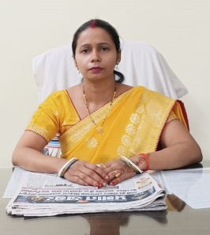

Priyanka Ranjan
Secretary,
Birsa College of Nursing, Chas, Bokaro

Greetings !

This nursing institute was established as a “Center Of Excellence” for nursing Education at the international & National level through quality approach, professional Development and research. Birsa College of Nursing strives to provide the best Nursing education that combines the development of cognitive, affective as well as Psychomotor domains of learning by adapting to recent technological advances.

We prepare and mould the students to be not merely a caregiver, but also a conﬁdent and Highly resourceful persons who can professionally handle the ‘state-of-the-art’ equipment in the hospital. Endowed with the unique qualities of love, courage and mercy which are The hallmarks of the nurse, our Birsa College of Nursing are much in demand in today’s modern health care system.

Principal

Be Proud to be Nurse, serve the humanity

Overview of the Programme

Nursing is a profession within the health care sector focused on the care of individuals, families and communities so they may attain, maintain or recover optimal health and quality of life. Nurses may be differentiated from other health care providers by their approach to patient care, training and scope of practice. Nurses practice in many specialties with differing levels of prescription authority.Education for the practice of professional nursing demands a substantial knowledge of nursing, drawing the foundation from knowledge of the behavioral and biological sciences. The nursing component includes lectures, laboratory and clinical courses concentrated in every nursing programme. The nursing courses include course work relevant to professional practice, delivery of nursing care, systems for care delivery and leadership skill development appropriate to current dynamic and diverse health care
settings. Clinical courses, offered in both hospital settings and the community, provide students with the opportunity to apply theoretical knowledge to practice.The Birsa College of Nursing follows the syllabus laid down by the Indian Nursing Council (INC). The Nursing curriculum allows students to take part in rural and urban health camps; educational ﬁeld visits, industries etc. This nursing programme is based

on education within an academic framework speciﬁcally directed to the development of critical thinking skills, competencies and standards required for practice of professional nursing. Nursing education programmes prepares its graduates into an admirable citizen by adhering to code of ethics and professional conduct at all times in fulﬁlling their duties…. At the end of the programme, students are well equipped with knowledge and skills to pursue a career in Nursing.

Medium of Instruction
Medium of instruction and Examination are in Hindi / English
Name of The Course | Duration | Criteria
General Nursing & Midwifery (GNM) | 3 Years | - Minimum Education:  - 10+2 class passed any stream  & English with aggregate of  40% marks.  - 10+2 in Arts (Mathematics,  Biotechnology, Economics, Political  Science, History, Geography,  Business Studies, Accountancy,  Home Science, Sociology,  Psychology, Philosophy) and  English Core/English Elective or  Health care Science- Vocational  stream ONLY, passing out from  recognized Board under AISSCE/  CBSE/ICSE/SSCE/HSCE or other  Equivalent Board with 40% marks.  - 10+2 vocational ANM under CBSE  Board or other equivalent board  from the school and recognized by  Indian Nursing Council with 40%  Marks.  - Student shall be medically ﬁt.  - Student qualiﬁed in 10+2 Arts or Science  examination or Health care Science-  Vocational stream ONLY conducted by  National Institute of Open School with  40% marks  - Student shall be Admitted once in a year  For SC/ST candidates, there will be relaxation of 5% marks.
Auxiliary Nursing Midwifery (ANM) | 2 Years | - Minimum Education:  - 10+2 class passed any stream  - Student shall be medically ﬁt.

Admission Criteria

Admission Procedure
Candidates should submit the prescribed application form duly completed along with
Requisite documents.
Documents required at the time of admission:
- Certiﬁcate of passing the qualifying examination
- Mark sheet of H.S.C.
- Mark sheet of S.S.C./S.S.L.C (Orignal)
- Transfer Certiﬁcate or School Leaving Certiﬁcate, Migration certiﬁcate original
- Caste certiﬁcate issued by the competent authority, if admission is against
Reserved category
- Character/Conduct Certiﬁcate
- Aadhar Card, Voter ID

Infrastructure / Physical Facilities
Lecture Halls
The college has sufficient and specious lecture halls for each batch. They are well Ventilated.
The desks are well spaced out. Each lecture hall has the facility to use latest Audio-Visual teaching aids.

Laboratories
We have spacious with fully equipped laboratories where various procedures have been demonstrated to students and allowed students to practice. Aim is to give complete practical training in each department to develop their knowledge and skill.
Laboratories are as follows:
1) Nursing Foundation Lab.
2) OBG Lab
3) Child Health Nursing (Pediatric) Lab
4) Nutrition Lab
5) Community Health Nursing Lab.
6) Advanced skill Lab.
7) Pre clinical Science Lab. (Bio-chemistry, Microbiology, Anatomy & Physiology)
8) Computer Lab.
Computer lab and Pre clinical Science laboratories (Bio-chemistry, Microbiology, Anatomy Physiology) are in the D. Y. Patil Medical College, excellently equipped with latest technology where students can learn and enhance their knowledge.

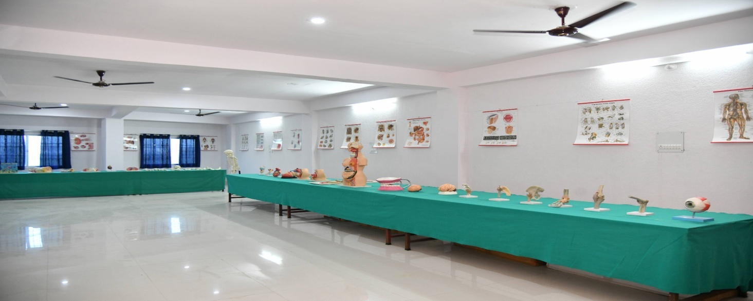

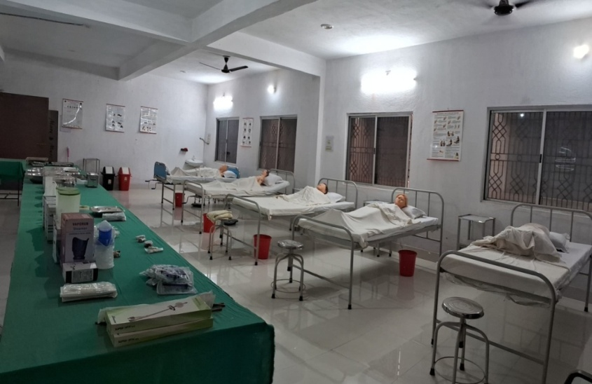
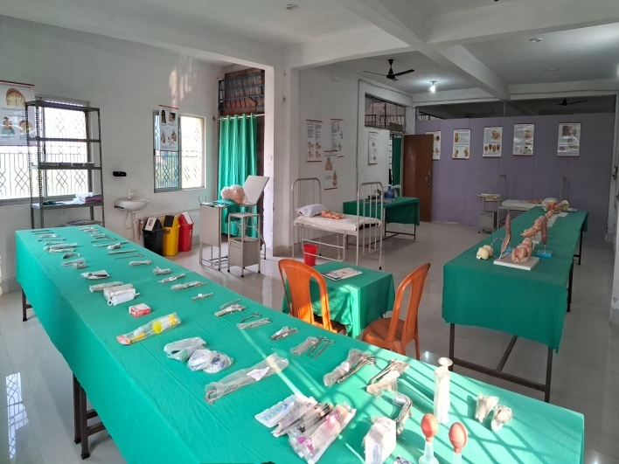
Anatomy Lab

Fundamental lab
Obstetric and Child Health lab

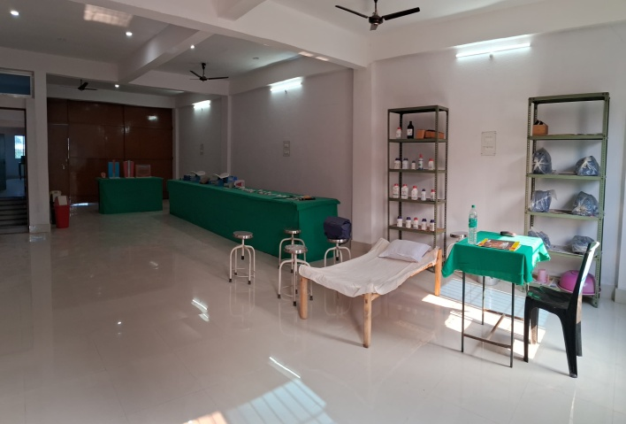

Community lab
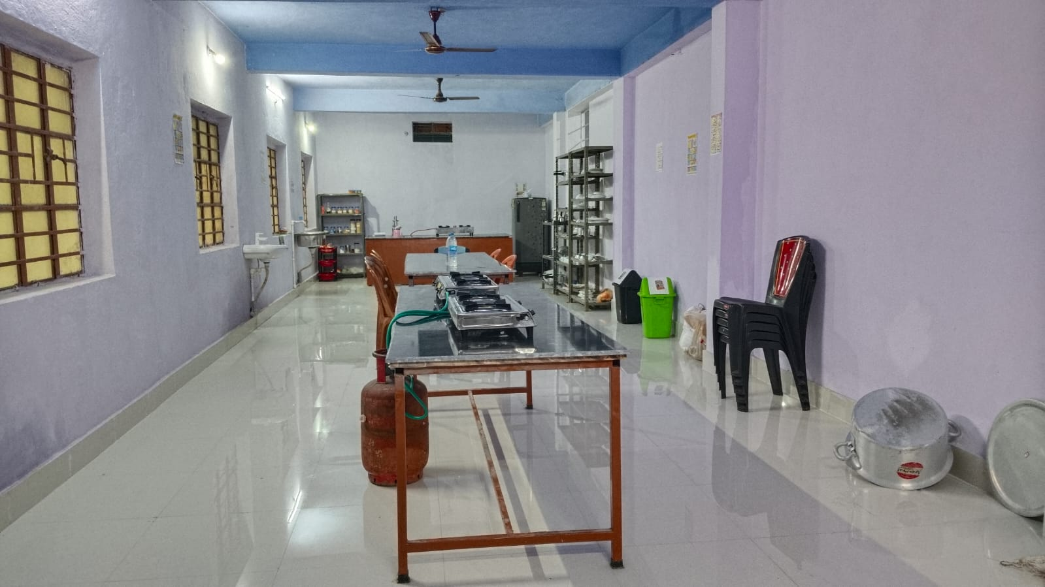

Nutrition lab
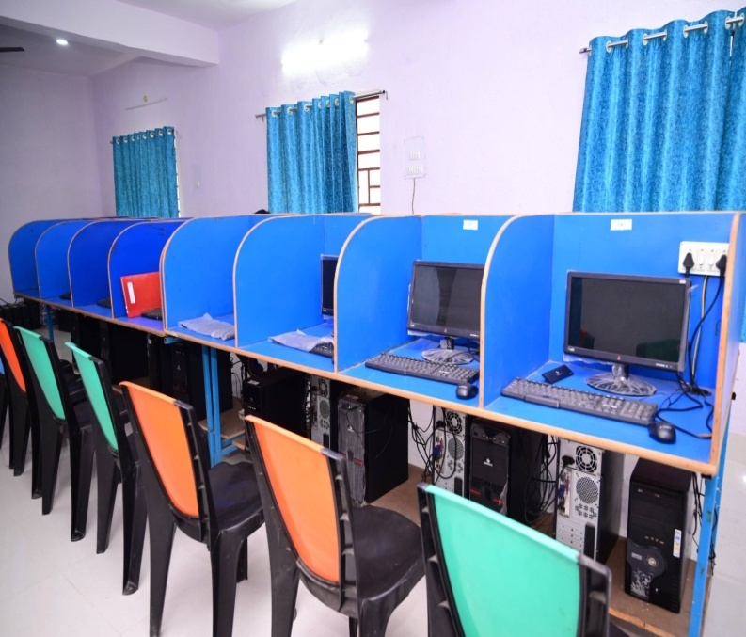
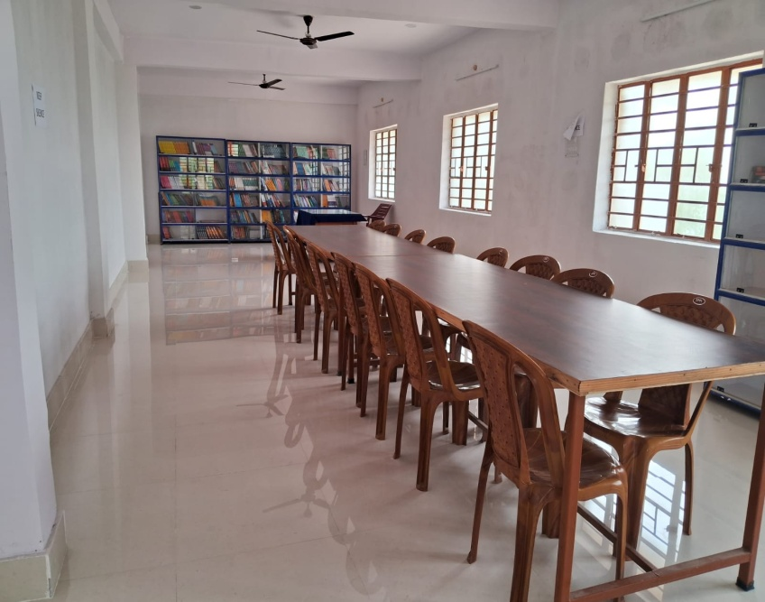

Computer Lab
Library

Anti-Ragging and Sexual Harassment Committee
Ragging in any form is strictly prohibited. In case the applicant for admission is found to have indulged in ragging in the past or if it is noticed later that he/she has indulged in ragging, admission can be refused or he/ she shall be subjected to penal action as per provisions of law, also expelled from the college, as detailed in the law concerned and as per Hon’ble Supreme Court of
India directions in this regard. After the admission is conﬁrmed each student has to give undertaking regarding non involvement in ragging.

Anti Sexual Harassment Committee
Anti Sexual Harassment Committee, comprising of members from the teaching and non-teaching staff as well as students looks into matters related to sexual harassment of students and staffs in the college. The boards indicating the names, their phone
numbers of the committee members are displayed in the college.

Transport
The college buses are available for students toprovide practical exposure of community urban/ rural, certain ﬁeld visits and trips.

Play Ground
The Nursing College has a well specious playground where students can practice various outdoor games. Sport day is conducted annually where students compete their sports events

Ragging
Ragging in any form is a punishable offence and committing this act of indiscipline shall result in instant cancellation of the concerned student’s admission to the course or into his/her rustication. It must be noted that the institute considers ragging a cognizable offence and will not hesitate to take strong action against the offenders. Here are the extracts from the INC/JNRC Committee Report.
Guidelines given by the University Grants Commission to Curb the Menace of Ragging in Universities/Educational Institutions.
The word “Ragging” means the act of teasing, taunting, playing a practical joke upon someone or holding comic parades and other activities during certain period of a college term to raise money for charity.

- Forms of ragging: Ragging is found to take the following forms (the list is only
indicative and not exhaustive)

- Crisp Orders
  - To address seniors as ‘Sir’
  - To perform mass drills;
  - To copy class notes for the seniors;
  - To serve various errands;
  - To do menial jobs for the seniors;
  - To ask/answer vulgar questions;
  - To look at pornographic pictures to shook the freshers out of their innocence;
  - To force to drink alcohol, scalding tea, etc.
  - To force to do acts with sexual overtones, including homosexual acts;
  - To force to do acts which can lead to physical injury/mental torture or death;
  - To do other obscenities

- Punishments
- Cancellation of admission
- Suspension from attending classes.
- Withholding/withdrawing scholarship/fellowship and other beneﬁts.
- Debarring from appearing in any test/examination or other evaluation process.
- Withholding results.
- Debarring from representing the institution in any national or international
meet, tournament, youth festival, etc.
- Expulsion from the hostel.
- Rustication from the institution for periods varying from 1 to -1 semesters
- Expulsion from the institution and consequent debarring from admission to
any other institution.
- Fine up to Rs. 25,000/-
- Rigorous imprisonment up to three years.
While the First 10 types of punishment can be awarded by the appropriate authority of
the institution itself, the last punishment can be awarded only by a court of law.
All the Best!

Address: By Pass Road, Chas, Bokaro, JHARKHAND -827013
Website: bcn.org.in, Email: bcnbokaro22@gmail.com, bcnbokaro25@gmail.com
PH: 06542-235225, 7759809333,7759805333

